CA-36
2016 IE Strategy Memorandum

Updated on 5/17/16

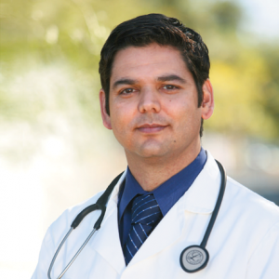
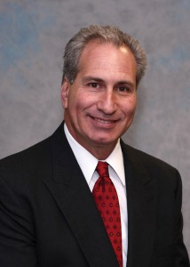

RAUL RUIZ JEFF STONE
CoH: $1,852,107.69 CoH: $102,491.21
Date: 4/15/16 Date: 4/15/16
Occupation: Congressman/ Emergency Physician Occupation: Pharmacist/ California Senator

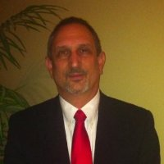

STEPHAN WOLKOWICZ
CoH:
Date: 4/15/16
Occupation: Financial Accountant

SECTION I: Race Overview
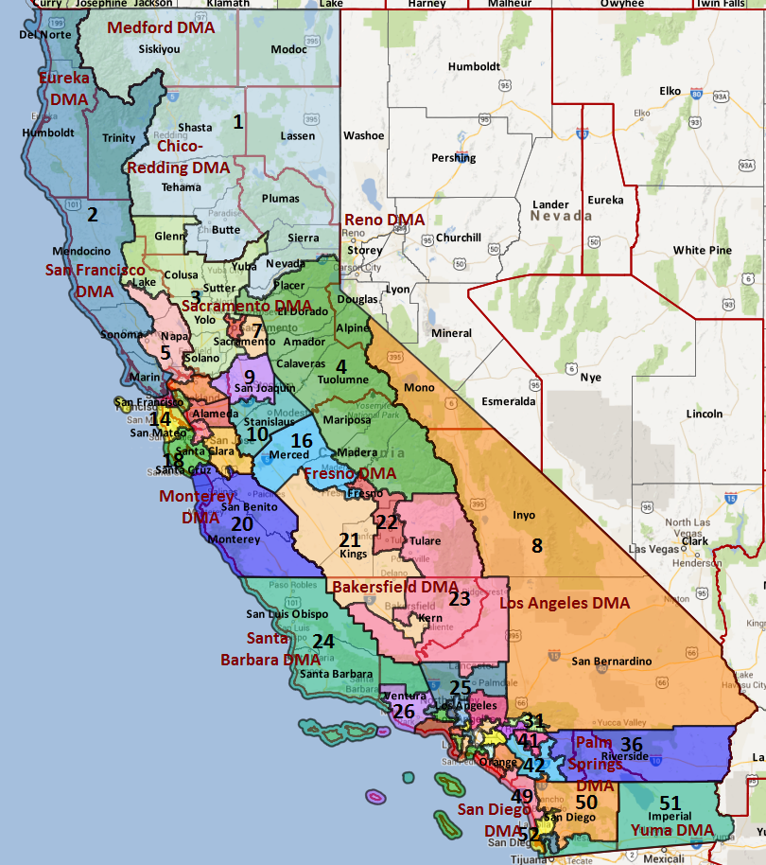

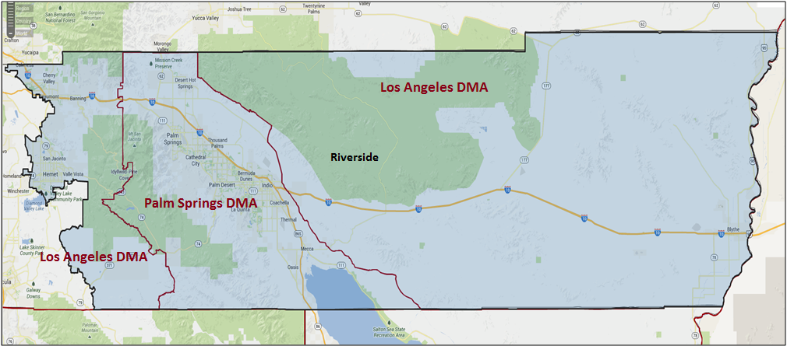

Media Market Costs

TV DMA | % of  CD | I.E.  35+ CPP | Cable CPP
LOS ANGELES | 100% | $1906 | $505
PALM SPRINGS | 61% | $120 | $595
CA-36TOTALS: | 100.0%
Radio Landscape

Palm Springs
Universe Size | CPP
230,100 | $53

Riverside
Universe Size | CPP
737,800 | $450

Digital Landscape
  - Persuasion universe size: 21,979
  - Audience extension (key demos): Hispanic, 18-45
  - Weekly budget for full coverage: $7,974.00
  - Reach
    - YouTube - 346,259
    - Pandora – 212,200
Presidential Statistics
Cycle | Candidate | Party | Vote
2012 | Obama | DEM | 51.6%
2012 | Romney | REP | 48.4%
2008 | Obama | DEM | 51.1%
2008 | McCain | REP | 48.9%

Congressional Statistics
Cycle | W/L | Candidate | Party | Vote
2014 | W | RUIZ | DEM | 54.1%
2014 | L | NESTANDE | REP | 45.8%
2012 | W | RUIZ | DEM | 52.9%
2012 | L | BONO-MACK | REP | 47.1%

NCEC Data
Dem Performance: 50.5%
BVAP: 4.6%
Hispanic: 31.3%
Asian: 3.3%
Total Minority: 39.2%

Critical Dates
Filing Date: March 25th 2016
Primary Date: June 7th 2016

Summary of 2014 Cycle Spending by Outside Groups to Date
TV Competitive Summary – Los Angeles
Campaign/Group |  | Total GRPs |  | Total Dollars
Nestande/NRCC |  | 53 |  | $13,083
Good Guys vs Bad Guys |  | Total GRPs |  | Total Dollars
Good Guys |  | X |  | X
Bad Guys |  | $53 |  | $13,083
TV Competitive Summary – Palm Springs
Campaign/Group |  | Total GRPs |  | Total Dollars
Nestande/NRCC |  | 1,577 |  | $83,864
House Majority PAC |  | 1,249 |  | $174,215
Inland Empire Taxpayers Association |  | 267 |  | $32,050
American Society of Anesthesiologists |  | 1,186 |  | $148,225
Good Guys vs Bad Guys |  | Total GRPs |  | Total Dollars
Good Guys |  | 1,249 |  | $322,440
Bad Guys |  | 1,844 |  | $115,914

Summary of 2012 Spending by Outside Groups

Competitive Summary -- Palm Springs
Campaign/Group | GRPs | Total Dollars
Bono Mack / NRCC | 944 | $88,000
DCCC | 3300 | $997,292
NRCC | 3,127 | $609,680
House Majority PAC | 2,070 | $308,461
American Unity PAC | 931 | $166,917
CA for a Stronger America | 677 | $95,261
CA for Strong Am (Hispanic) | 381 | $9,515
Crossroads GPS | 1,778 | $332,914
Good Guys vs Bad Guys | Total GRPs | Total Dollars
Good Guys | 6,301 | $1,472,670
Bad Guys | $5,963 | $952,109
TV Competitive Summary -- Los Angeles
Campaign/Group | GRPs | Total Dollars
American Unity PAC | 220 | $229,512
Good Guys vs Bad Guys | Total GRPs | Total Dollars
Good Guys | 220 | $229,512
Bad Guys | X | X

Pre-Election Day Voting

Type of  “Early Voting” | Start Date  End Date | Percent of  Vote Cast Using this Method | Brief Description  (where/how  do people vote) | Timeframe (when does the majority of voting happen)
Early Vote | Oct 10 –Nov 8 |  | Voters can bring their early ballots to the board of elections office or be issued a ballot at the office at the time of their visit | Steadily between Oct 8 – Nov 7
Absentee Ballot/In person Absentee | Oct 10 – Nov 11 |  | Voters must apply for an absentee/VBM ballot via mail, online, or in person | Absentee applications must be received by BOE at least 7 days before election day
Vote By Mail | Oct 1 – Nov 11 |  | Voters must request to VBM each election unless on PEVL - VBM must be received by BOE by Nov 11 and be postmarked before election day | Ballots return steadily.

Tentative Campaign Timeline

IMPORTANT DATES

VBM: Oct. 10 – Nov. 1

EARLY/ ABSENTEE VOTING:
- Counties will begin sending out mail ballots on October 10, 2016. Voters may submit a mail application to vote by mail by November 1, 2016 and can apply to vote by mail in-person thereafter. Voters can vote early at the Riverside County Registrar of Voters Office 29 days before Election Day.
- Mail ballots comprise a large portion of ballots cast in CA-36. According to Political Data Inc’s database (PDI), there are about 173,000 voters classified as permanent absentee voters (PAV) in the district.
- 71% of 2014 ballots cast were cast via mail and 62% of ballots cast in 2012 were cast via mail.
- Registered Republicans had a 3-point advantage with returned VBM ballots in 2012 and a one-point advantage with 2014 mail ballots. Despite the partisan deficit, Ruiz won 54.6% of mail votes in 2014 and 50.9% of mail votes in 2012, according to official election results.
- In 2012, 6% of mail ballots were returned three weeks out, 36% of mail ballots were returned two weeks out and 59% were returned a week out. In 2014, slightly more ballots were returned in weeks two and three: 5% of ballots were returned three weeks out, 44% were returned two weeks out and 75% were returned one week out from Election Day.
Conservatively using the 2014 Election Day support rate of 53.1% and the VBM vote rate from the last Presidential cycle, Ruiz will need to win 50% of mail ballots to win 52% of the total ballots cast.

SECTION II: DISTRICT OVERVIEW

- District Overview and Data

  - Political Landscape
- A Harvard-educated emergency room physician, Congressman Ruiz is running for his third term in 2016. Ruiz has two Republican challengers. State Senator Jeff Stone has announced his candidacy and represents roughly 66% of the district (by registration) (see map on final page). Stone won his last re-election in 2014 by 6 points. Attorney and former Marine Dwight Kealy also announced he is running as a Republican. Kealy lives outside the district in neighboring Temecula and has never held public office.
- Per an IVR tracking poll conducted in October 2015, Ruiz is popular in the district (43% fav to 15% unfav, 42% undecided), but most voters were unsure how they would vote. When asked if they would vote to reelect Ruiz or vote for someone else, 39% of respondents said they would reelect Ruiz, 27% said they would vote for someone else and 35% refused or were undecided.

  - District Demographics
- California’s 36th District is located in the eastern portion of Riverside County, stretching from Palm Springs to the Arizona border. It includes Palm Springs, Palm Desert, Indio, Coachella, Desert Hot Springs, and portions of the Inland Empire.
- CA-36 includes two media markets: the cost-prohibitive LA media market (41% of the district) and the inexpensive Palm Springs market (59% of the district). The political CPP is $90 in Palm Springs and $1,589 in Los Angeles. Spanish language media is also a key consideration in this district, as an estimated 33.4% of district residents speak Spanish.
- Ruiz is one of the only Hispanic Members of Congress representing a majority-White district.
- 18.7% of CA-36’s population is over 65 years-old, the highest percentage of any district in the state, and 38.0% of the district’s residents are on Social Security. CA-36 also has a high share of veterans, at 11.6%. The district is mostly suburban (66.3%), but includes some urban areas (10.3%) and large rural areas (23.5%) in the district’s east and center. The large population centers are located in the West, while small, mostly Hispanic, communities stretch along I-10 east of Indio and Cochella.
- California is a party registration state. Voters register for a party or “decline to state.” Unless otherwise noted, all party references in this document represent party registration.

District Demographics

- Cook Partisan Voting Index:
- Urban Population: 10.3%
- Suburban Population: 66.3%
- Rural Population: 23.5%
- Median Income: $44,446
- Poverty Status: 12.1%
- Military Veterans: 11.6%
- Race/Ethnic Origin: 83.9% White; 4.6% Black; 3.3% Asian; 31.3% Hispanic

  - Electoral Context
- If Loretta Sanchez makes it into the Senate General Election contest, she will likely target the large Latino population in both media markets. That being said, Ruiz is unlikely to tie his messaging to a top-of-ticket candidate, since he has consistently over-performed Democratic candidates higher on the ballot.
- It is now much easier for a ballot initiative to qualify for the ballot, and we, therefore, expect a very high number of ballot measures to appear in 2016. Ballot initiatives that may impact the electorate include:
- A “Fight for $15” minimum wage increase that is being sponsored by SEIU
- A possible initiative that will legalize the recreational use of marijuana
- A ban of the possession and sale of large ammunition clips
- Proposition 30 extensions that would continue higher income tax for the wealthiest Californians
- School Funding and Budget Stability Act that would extend Prop 30’s income tax increases through 2030 and fund K-12 education
- The “Invest in California’s Children Act,” which would impose higher rates on individual tax filers earning more than $1 million per year.
- One major election rule change will influence our race in 2016. Senate Bill 29, which rules boards of elections must count absentee ballots that arrive up to three days after the election that are postmarked on or before Election Day. Previously, only ballots received by Election Day counted. The new DMV voter registration law will not take effect in time for the 2016 cycle.

  - Press Presence
The LA Media Market has been virtually impenetrable for earned media.
The Palm Springs Media Market:
Broadcast:
- Univision, anecdotally, is the most watched station. They give Ruiz a weekly slot to speak on any issue he would like.
- ABC, FOX, CBS, and Telemundo are all in one building, run by Rich Taring and a another news director
- KMIR (NBC)
Print:
- The Desert Sun - Paper of Record, key reporter is Jesse Marx, though his politics editor is much more conservative
- The Press-Enterprise - key (more conservative reporter) Jeff Horseman, covers both Ruiz and Aguilar

SECTION III: MESSAGE

Message Box

Democrat Self Frame  Ruiz has helped create new manufacturing jobs in the area and has secured over $1 million for small businesses.  He has upheld his promises to protect Social Security and Medicare for seniors, and stood up for veterans to make sure they receive the benefits they have earned.  Dr. Ruiz spends his time helping veterans, seniors, and working families, and knows a balanced budget is crucial to the economic success of our country. He has even stood up to Nancy Pelosi and the Obama administration on these issues. | Republican Self Frame  Jeff believes in a fiscally responsible and more efficient government that is less intrusive and more productive for its citizens. He is a strong advocate for policies that foster economic growth and job expansion and a champion for taxpayers. Jeff makes public safety a top priority. Stone created the county’s first juvenile sexual predator interdiction program and passed a county resolution making it easier for law abiding citizens to carry concealed firearms for personal protection.
Likeliest Attacks on Democrat  Obama/Pelosi Democrat, voted with them XX percent of the time, supports higher taxes, defends Obamacare, not doing anything to reduce the deficit.  Voted for the Iran deal.  Congressional perks, taxpayer salary. | Best Attacks on Republican

- Raul Ruiz (D)

- Short Biography
U.S. Representative Raul Ruiz, M.D., grew up in the community of Coachella, California, where both of his parents were farmworkers.
Dr. Ruiz achieved his lifelong dream of becoming a physician through public education. After graduating from Coachella Valley High School, Dr. Ruiz graduated magna cum laude from UCLA.
Dr. Ruiz continued his work as an Emergency Room Doctor until he was elected to the U.S. House of Representatives in 2012.

- Self-Frame
Ruiz has helped create new manufacturing jobs in the area and has secured over $1 million for small businesses.
He has upheld his promises to protect Social Security and Medicare for seniors, and stood up for veterans to make sure they receive the benefits they have earned.
Dr. Ruiz spends his time helping veterans, seniors, and working families, and knows a balanced budget is crucial to the economic success of our country. He has even stood up to Nancy Pelosi and the Obama administration on these issues.

- Likely Attacks
Obama/Pelosi Democrat, voted with them XX percent of the time, supports higher taxes, defends Obamacare, not doing anything to reduce the deficit.
Voted for the Iran deal.
Congressional perks, taxpayer salary.

- Assessment of Democratic Fundraising

Ruiz | Q1 2015 | Q2 2015 | Q3 2015 | Q4 2015 | Q1 2016
Goal | N/A | $500,000 | $500,000 | $425,000 | $475,000
Actual Raised | $381,056 | $433,743 | $415,016 | $341,175 | $460,593

- Strengths and Weaknesses of Campaign
Rep. Ruiz has a very strong earned media presence in the district, particularly the 59% of the district in the Palm Springs media market.
The NRCC got significant bad press after Mayor Lupe Ramos Watson’s exit from the race about their recruitment failures here, but Stone appears to be their recruit in the race. Rep. Ruiz is concerned with Stone’s campaign, and believes that he will raise over $500,000 in Q1.
Rep. Ruiz has gone through significant staff changes on his campaign and official side staff, but is interviewing campaign managers earlier this cycle than he has in the past.

- Jeff Stone

- Short Biography
Jeff Stone has lived in Southern California his entire life. He moved to Riverside County because of the quality of life it offered. Jeff knew this was one of the best places to open a business and raise a family.
In 2014, Jeff Stone was elected to the State Senate, in spite of being outspent by over 2 to 1 margin.

- Self-Frame
Jeff believes in a fiscally responsible and more efficient government that is less intrusive and more productive for its citizens. He is a strong advocate for policies that foster economic growth and job expansion and a champion for taxpayers. Jeff makes public safety a top priority. Stone created the county’s first juvenile sexual predator interdiction program and passed a county resolution making it easier for law abiding citizens to carry concealed firearms for personal protection.

- Best Attacks

Republican Candidate | Ryan Budget(s) – (Include if its Votes or Statement) | Privatize Social Security | Defund Planned Parenthood | Anti-Choice Position
Stone |  |  |  | X

Stone Top Hits

- Does not live in the district. [Nexis Comprehensive Person Report, accessed 1/07/16]
- Stone’s pharmacy businesses have been and are currently suspended by the franchise tax board for failure to meet tax or business filing requirements. [California Secretary of State, accessed 3/04/16]
- Has had multiple tax liens issued by Riverside County. [Nexis]
- His pharmacy license was placed on probation for three years and he was fined to settle four administrative violations with the state board of pharmacy. [East County Magazine, May 2010; San Diego Union-Tribune, 8/06/03]
- Had the license for one of his pharmacies revoked in 1999 for disciplinary reasons. [California Board of Pharmacy, accessed 3/04/16]
- Had another license canceled in 2010, though it has since been renewed. [California Board of Pharmacy, accessed 3/04/16]
- Sued in 2003 for filling a prescription with a “lethal” concentration of a thyroid drug. [San Diego Union-Tribune, 8/06/03]
- Accused of abusing power through flashing an honorary police badge to intimidate another motorist. [Various]
- His campaigns have been fined three times since 2006 over irregularities and most recently for $5,500 in 2015. One of nation’s largest potato growers was even arraigned for illegally funneling donations to Stone’s campaign. [Various]
- Voted against capping out-of-pocket prescription drug costs. [AB 339, 9/10/15; Assembly Daily Journal, 9/11/15; Bill Analysis, 9/04/15; SCPR, 10/08/15]
- Previous campaign biography stated that “he recognizes the sanctity of life, that life begins at conception and that abortion is wrong.” [SmartVoter – Jeff Stone Biography, 2010]
- Defended SB1070. [East County Magazine, May 2010]
- Voted against raising the California minimum wage. [SB 3, 6/01/15; Los Angeles Times, 6/01/15]
- Attended a town hall meeting filled with anti-immigration activists where he criticized the national government for lacking “political will to protect our borders” – these protestors had earlier prevented buses from offloading refugee children into the town. [Various]
- Proposed constructing prisons and tent jails in the desert like those made famous by Joe Arpaio. [Desert Sun, 11/02/13]
- Opposed bill that would require California to increase use of renewable energies and require energy efficiency to be doubled in homes, offices, and factories. [SB 350, 9/11/15; SB 350, 6/03/15]
- Opposed Iran nuclear deal and said Ruiz’s support was what led him to run [Desert Sun, Stone Op-Ed, 9/26/15]
- Stone has reported assets totaling several million dollars, but the actual total is unclear due to errors in his reporting. Nearly all his assets are illiquid real estate or LLC ownership stakes. [Jeffrey Earle Stone Federal Personal Financial Disclosure, 3/21/16]
- Stone has no known statements on Trump to date.

SECTION V: Appendix

- 2016 Campaign Side Consulting Team
Media: Behr Communications - lead: Behr
Mail: BZD - lead: Bergmann
Polling: Lake Research Partners
Online/Digital: Mothership
Self-research: Lake Research

- Summary of Past Races and Important Differences for 2016
Recent Elections
- By a slim 0.1% margin, President Obama’s 2012 vote-share (51.6%) outpaced his 2008 performance (51.5%). Obama performed best in the cities of Palm Springs, Indio, Cathedral City, Coachella and Desert Hot Springs.
- In 2012, Ruiz surprised Republicans by outpacing both average Democratic performance and President Obama in CA-36 to unseat incumbent Rep. Mary Bono Mack. Ruiz won with 53.0% of the vote, with his highest levels of support (above 60%) in the cities of Palm Springs, Indio, Cathedral City, Coachella, and Desert Hot Springs. These high levels of support were due in large part to Ruiz’s success with Hispanic voters.
- Ruiz began 2014 with double-digit leads over challenger Brian Nestande and maintained his lead until near the end of the election—impressive given the district’s 47.3% DPI at the time. Rep. Ruiz often crossed the 50% support mark in polls even as the generic Republican continued to outperform the generic Democrat. Registered voter turnout was under 50%, but Rep. Ruiz laid the necessary groundwork—and won 54.2% of the two-way vote.
- The 2016 DPI of 50.5% represents a 3.2 point increase from 2014 and a 3.3 increase from the 2012 DPI of 47.2%.

Role of the I.E.
The DCCC IE monitored this race closely and was prepared to protect Congressman Raul Ruiz if Republican Brian Nestandate gained traction. Our polling repeatedly showed Ruiz ahead by 10 points – with many persuadable voters in the Los Angeles market, which Nestande could not afford to spend in. In addition, Ruiz maintained a significant cash advantage over Nestande. As a result, the IE never bought in TV in this district.

In 2012, the role of the Raul Ruiz campaign and IEs was straightforward. The IEs covered the inexpensive Palm Springs DMA, enabling the campaign to spend at the lower candidate-rate in the Los Angeles DMA, a market effectively cost prohibitive for IEs (at the issue rate). In 2014, our strategic plan was to emulate this “divide-and-conquer” approach if we needed to play – though there was some disagreement to that overall strategy when polling showed that the Los Angeles market included a large share of persuadable voters. Ultimately, the point was moot as the DCCCC IE Program never communicated with voters in the district in 2014.
The total DCCC IE Program investment in CA-36 was $43,277 – all on polling.

2016 Electorate
- According to official County election results from the 2012 election, 73.6% of registered voters voted (215,579 ballots cast).
- Applying this turnout rate forward to the current electorate as defined by the Secretary of State, we can expect to see 205,114 voters or 73.6% of the electorate, cast ballots in the 2016 General Election.
- As a result, a successful campaign will need 106,659 raw votes to reach a 52% support goal. A one-point shift in support equates to 2,051 votes.
- We project the 2016 vote share will include about 5% more Hispanic voters, 6% more young people aged 18-29 and 2% more DTS voters than the 2014 electorate. Registration, per the Secretary of State, has also decreased by 3,602 registrants since the 2014 General. Democratic registration stayed static (0.03% increase), while Republican registration decreased 0.37%. DTS registration increased by 0.3%.
- Ballot roll off was -2.3% for all voters, but a clear ticket splitting pattern emerged in the district: 2.1% more voters voted for Ruiz than Obama and 3.2% of Romney voters did not vote for Bono Mack.
- Per national turnout and generic support models developed early in 2016, strong Democratic base communities include Palm Springs, Indio, Cathedral City, Coachella, and Desert Hot Springs (all located in and around the Los Angeles Media market), where a large number of Hispanic voters reside. Persuasion targets live around Rancho Mirage, Cathedral City, Thousand Palms and the eastern portion of the district. Turnout targets live outside the core base areas to the west, south and east of the Thousand Palms, Bermuda Dunes, La Quinta area.

DEMOCRATS START THIS RACE AHEAD BY 1,695 VOTES (52.8% TWO-WAY SUPPORT).VICTORY DEPENDS ON THE FOLLOWING:
- MAXIMIZE SUPPORT (TO 76.7%) AND TURNOUT (TO 74.2%) WITHIN THE HISPANIC COMMUNITY WHILE STAYING ABOVE 42% SUPPORT WITH WHITE VOTERS
- CONTINUE TO CONSOLIDATE VOTERS IN THE PALM SPRINGS MEDIA MARKET TO INCREASE SUPPORT ABOVE 56.0% AND ACHIEVE AT LEAST A 45.0% SUPPORT RATE IN THE LOS ANGELES MEDIA MARKET
- MAINTAIN SUPPORT IN THE SENIOR COMMUNITY AT 49.6%, AS SHOWN IN 2014
- WIN AT LEAST 57% OF INDEPENDENT VOTERS
- WIN 50.0% OF VOTE-BY-MAIL BALLOTS

